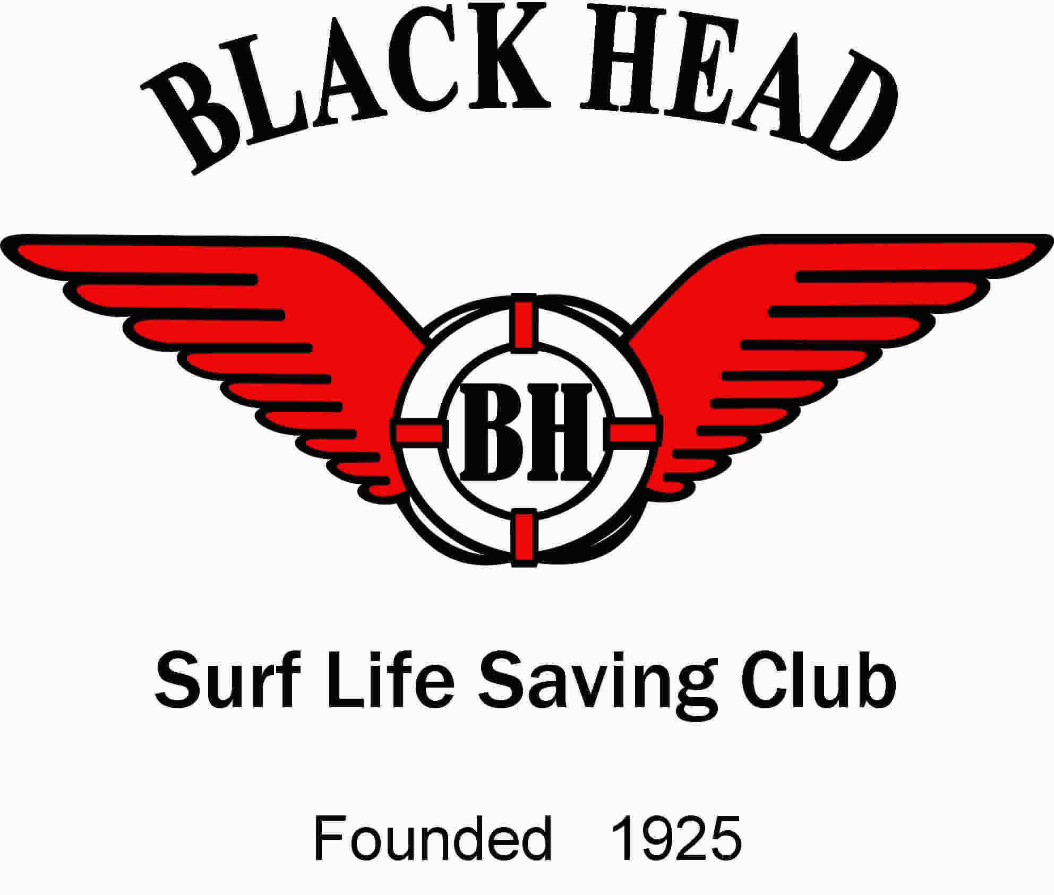

#### May be an image of 5 people and kayak

#### Annual Report 2022-2023

#### BOARD OF DIRECTORS 2021-2022

|  |  |  |  |
| --- | --- | --- | --- |
| *President:* | Dr Bruce White | *Director of Lifesaving:* | aRoss Blowers |
| *Vice President:* | Terry Aldridge | *Director of Surf Sports:* | Kevin Boag |
| *Director of Administration:* | David Bowland | *Director Junior Activities:* | Ian Marshall |
| *Director of Finance:* | Stuart Horsburgh | *Public Officer:* | Michael Bartlett OAM |
| *Director of Education:* | bNick Wisemantel |  | a Resigned 29 April 2023 |
|  | b Resigned 18 March 2023 |  |  |

**OFFICE BEARERS**

|  |  |  |  |
| --- | --- | --- | --- |
| *Branch Delegate:* | Dr Bruce White | *Registrar:* | Kerri Elliott |
| *First Aid Officer:* | Peter McErlain | *IRB Captain:* | Joel Spychala |
| *Licensee:* | Terry Aldridge | *Gym Coordinator:* | Ron Bridges |
| *Functions Coordinator:* | Kerri Elliott | *Bar Managers:* | Terry Aldridge,  Ron Bridges,  John Hannigan |

#### LIFE MEMBERSHIP AND HONOURS COMMITTEE

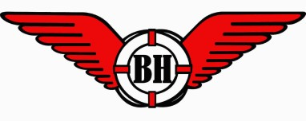

|  |  |  |
| --- | --- | --- |
| *Convener:* | John Edstein OAM |  |
| *Members:* | John Hannigan | Michael Bartlett OAM |
|  | Graeme Doig | Terry Aldridge |

#### PATRONS

|  |  |  |
| --- | --- | --- |
| P. Dahdah | B. Pain | Dr B. White |
| Dr David Gillespie MP | Johnny Walker | C. Pontin |

#### LIFE MEMBERS

|  |  |  |
| --- | --- | --- |
| A. Skinner OAM | J. Edstein OAM | G. Doig |
| B. Pain | P. Manusu | T. Aldridge |
| R. Bridges | J. Hannigan | B. McWhirter |

**LIFE MEMBERS (Deceased)**

|  |  |  |
| --- | --- | --- |
| F. Postle | Mrs J. Wisemantel | H. Bennett |
| F. Plummer | R. Plummer | T. Lynch |
| B. Moy | W. Scott | J. Maitland |
| Mrs A. Trotter | C. Woolcott | W. Warren |
| John Ritchie OAM | V. Goodwin | A. Whyte-Butler |

**Black Head Surf Life Saving Club**

**The 98th Annual General Meeting**

**will be held at the Black Head Surf Life Saving Club from**

**1 pm 8 July 2023.**

Welcome and Apologies

Confirmation of Minutes of the 97th Annual General meeting held 23 July 2022

Presentation and adoption of the Annual report

Presentation of the Financial Report and Balance Sheet

Election of Office Bearers for the 2023-2024 Season

Affiliation to be sought by Black Head SLSC with Surf Life Saving Lower North Coast Branch & Surf Life Saving NSW

Proposed: Terry Aldridge Seconded: Bruce White

Members are welcome to nominate for Office positions by firstly reading and accepting the skills required and the responsibilities for that position. These are found in the By-laws on the club website **blackheadslsc.com.au**

Please have all nominations submitted to the Director of Administration by 1 July 2023. A form for nomination follows. Members wishing to vote must be financial. If financial for the 2022/2023 season, you will still be financial for the AGM.

The bar will be open for a short interlude of drinks and nibbles before the

Presentation Night starting at 3 pm.

**Black Head Surf Life Saving Club Objectives**

(a) Provide for the conduct, encouragement, promotion, and administration of surf lifesaving in the local area.

(b) Participate as a member of SLSNSW and SLSA through and by which surf lifesaving and the preservation of life in the aquatic environment can be conducted, encouraged, promoted, advanced and administered.

(c) Ensure the maintenance and enhancement of the Club, and surf lifesaving, its standards, quality and reputation for the benefit of the members and surf lifesaving.

(d) At all times act on behalf of and in the interest of the members and surf lifesaving.

(e) Promote the economic and community service success, strength and stability of surf lifesaving.

(f) Affiliate with and otherwise liaise with SLSNSW and SLSA in the pursuit of these objects and surf lifesaving.

(g) Conduct, encourage, promote, advance, and control surf lifesaving in the local area, its many aspects devoted to aquatic safety and management, and the preservation of life in the aquatic environment.

(h) Apply the property and capacity of the Club towards the fulfilment and achievement of these objects.

(i) Promote the involvement and influence of surf lifesaving standards, techniques, awards and education with bodies involved in lifesaving.

(j) Strive for Governmental, commercial, and public recognition of the Club as the authority on aquatic safety and management in local area.

(k) Foster, regulate, organise, and manage assessments, competitions, displays and other activities and to issue badges, medallions and certificates and award trophies to successful members.

(l) Review and/or determine any matters relating to surf lifesaving which may arise, or be referred to it, by any Member.

(m) Represent the interests of its members and of surf lifesaving generally in any appropriate forum.

### 

### 

### Categories of Club Membership

1. **Probationary Members** shall be the designation of any person for the time between applying for membership and the granting of a formal category of membership of the Club. Probationary Members are non-voting members of the Club.
2. **Junior Activities Members** shall be a person who shall be a minimum age of five (5) years and up to a maximum age of thirteen (13) years and such person shall be required to gain the relevant Surf Education Certificate for that person's age group. Junior Activities Members are non-voting members of the Club.
3. **Cadet Members** shall be a Member of the age qualification as defined in SLSA's Manuals (i.e. Under 15) and who has obtained the Surf Rescue Certificate or has passed the annual proficiency test. Cadet Members are non- voting members of the Club.
4. **Active Members**, who shall hold an SLSA Bronze Medallion, fulfil patrol and Club obligations and qualify in an annual proficiency test (unless that Member has obtained their Bronze Medallion in that season). Active Members shall have the right to be present, to debate and to vote at General Meetings.
5. **Reserve Active Membership** may be granted to Active Members who have satisfactorily completed (from gaining the Bronze Medallion) at least eight (8) years of patrol and Club obligations as provided by SLSA and Club Constitution. Reserve Active Membership shall not be automatic but shall be granted by a resolution of the Board. Reserve Active Members shall have the right to be present, to debate and to vote at General Meetings.
6. **Long Service Members** may be deemed as such by the Club after having completed ten (10) years active service or eight (8) years active service plus four (4) years reserve active service. These Members shall have the right to be present, to debate and to vote at General Meetings, and may be exempt from patrol obligations and granted other special privileges.
7. **Award Members** must hold an SLSA award of one or more of the following qualifications: Surf Rescue Certificate, Radio Award, Resuscitation Certificate, Advance Resuscitation Certificate or First Aid Certificate. Award Members may be granted voting rights by the Club Board if they are undertaking lifesaving patrol duties.
8. **Associate Members**, who may or may not have an SLSA award. Associate Members shall not have voting rights unless elected to office or position, which is provided voting rights by this Constitution.
9. **Honorary Members** may be granted to Members who may or may not hold an SLSA award. Honorary Members are non-voting members of the Club.
10. **Life Membership** may be granted by the Club to Members who have rendered distinguished, or special service and shall have the right to be present, to debate and to vote at General meetings.



**A look back at the 2022-2023 Season**

2022-2023 was another successful season in all aspects of

the club, as shown by the individual Board member’s report

in the following pages.

As we do more structural repairs to the club, there remains less and less to do. A nagging issue has been the rock gully next to our ramp access. This was a little difficult and required Engineering and Surveying input. It was not just the gully to manage but the full runoff coming down the slope.

Kevin Boag’s team were able address all issues, with the results looking fantastic. Our only disclaimer is to see how it performs with a significant storm.

Storage is always a problem for us. With his liquor Licence duties Terry has been able to develop a moderate sized storage room in the foyer. This is perfect for storing the paraphernalia that accompanies the bar. Once painted it blends in with the rest of the foyer.

Continuing the theme of storage space, the club really needs the use of a large shed big enough to store equipment such as a boat and 28-foot trailer. Please contact Terry Aldridge if you have one available.

The board has been contemplating changes to the Club gym to allow wheelchair access, recarpet the floor and revising the individual pieces of gym equipment to allow more space overall. We have recruited Bruce Pain and Ron Bridge as architect and project manager, they should have things ready by December.



**Membership Trends 2022****-2023**

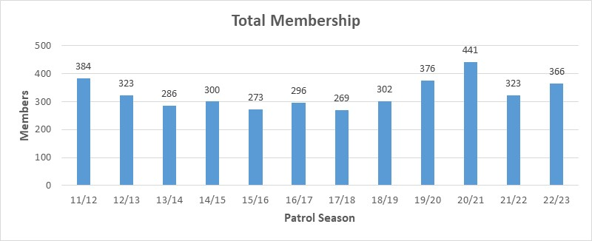

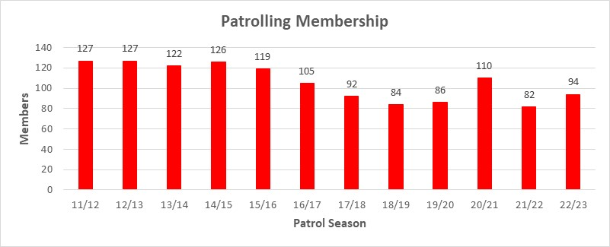

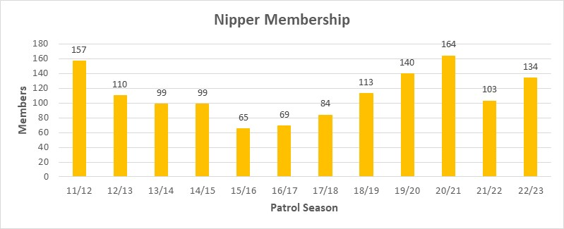

**Bar & V.P Report 2022 – 2023**

**Sunday Sippers**

This has been our main social activity during the year, and we have had good attendance at Sunday Sippers and the Christmas New Year period.

Graeme Studd and Breck Muir (aka Waldorf and Stanley), although not having to be COVID marshals, continue to be very active at Sippers.

Again, thanks to all those who have volunteered their time with Sippers and club social functions. And a special thanks to Steve Taylor from Cellarbrations at Diamond beach for his ongoing support of the club.

**Social**

Tania McKone ran 2 disco nights which was well supported by nippers and locals. Christmas drinks and end of season bar-b-que were well patronised and appreciated, thanks Ross.

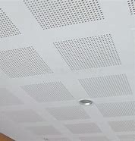

**Functions**

Thanks, Kerri Elliott, for all your hard work.

We have had complaints for years about the noise in the hall and how difficult it is to hear. This year we have had the hall assessed by Acoustic Engineers and have added the perforated Gypsum panels to the ceiling. With these changes, the new audio system and the Hearing Aid Loop system it presents a better hall for functions in the future.

**NRL Tipping Competition**

Jim Frewin has an NRL tipping competition going again this year with a big increase in tipsters.

On behalf of John, Ron & I, we would like to thank all those who help with the bar for volunteering their time at club social functions. In addition, thanks go to Stuart Horsburgh and John Edstein for fitting out the new storage cupboard.

Ron Bridges (Moe) John Hannigan (Larry) Terry Aldridge (Curly)

Bar Managers

BHSLSC Inc



|  |  |  |
| --- | --- | --- |
| **Black Head SLSC 27 DECEMBER 2022 – PATROL2 SUB**  **Patrol Attendees** | | |
| ROSS | BLOWERS | 5 HOURS |
| SUZANNE | GERRISH | 5 HOURS |
| NIGEL | PEGRUM | 5 HOURS |
| DAVID | BOWLAND | 3 HOURS |
| CATHY | BOWLAND | 3 HOURS |
| BRONWYN | NEW | 3 HOURS |
| SCOTT | GALE | 5 HOURS |
| PETER | GOLLAN | 5 HOURS |
| LAUREN | JORDAN | 2.5 HOURS |
| PETER | McERLAIN | 3 HOURS |
| BRUCE | WHITE | 5 HOURS |
| AARON | WILLIAMS | 5 HOURS |
| NICHOLAS | WISEMANTEL | 3 HOURS |
| RECHELLE | WILLIAMS | 5 HOURS |
|  |  |  |
|  |  | **TOTAL: 57.5 HOURS** |

|  |  |
| --- | --- |
| Terry Aldridge | Alannah Hawkins Munro |
| Ross Blowers | Erin Ireland |
| Callum Boag | Lauren Jordan |
| Izaac Boag | Paul Kremer |
| Kevin Boag | Luke Murray |
| Cathy Bowland | Bronwyn New |
| David Bowland | Michael Parsons |
| Mauricio Cobra Siqueira | Lucy Pearce |
| John Cooling | Ashliegh Pegrum |
| Brady Cross | Ella Pegrum |
| Michael Cross | Nigel Pegrum |
| Allysia Duncan | Michael Petersen |
| Michael Elliott | Robyn Smee |
| Scott Gale | Bruce White |
| Simone Gale | Aaron Williams |
| Sue Gerrish | Rechelle Williams |
| Kim Gollan | Sara Wilson |

**100% Patrols for 2022/2023 Season**



**Completed Awards for 2022-2023 Season**

|  |  |
| --- | --- |
| Allan, Jason | Bronze Medallion |
| Ayres, Mitchell | Bronze Medallion |
| Ayres, Sally | Bronze Medallion |
| Duncan, Allysia | Bronze Medallion |
| Ireland, Erin | Bronze Medallion |
| Jordan, Lauren | Bronze Medallion |
| Ljumanovic, Maya | Bronze Medallion |
| Murray, Luke | Bronze Medallion |
| Navratil, Mark | Bronze Medallion |
| Petersen, Elka | Bronze Medallion |
| Petersen, Michael | Bronze Medallion |
| Quadrio, Andrew | Bronze Medallion |
| Smee, Robyn | Bronze Medallion |
| Spychala, Joel | Bronze Medallion |
| Thomas, Andrew | Bronze Medallion |
| Thomas, Lee | Bronze Medallion |
| Thomas, Robyn | Bronze Medallion |
| Trautsch, Ben | Bronze Medallion |
| Woodlee, Dave | Bronze Medallion |
| Kippax, Bronte | Surf Rescue Certificate (CPR Endorsed) |
| Pegrum, Ashleigh | Surf Rescue Certificate (CPR Endorsed) |
| Pegrum, Ella | Surf Rescue Certificate (CPR Endorsed) |
| Hawkins-Munro, Alannah | Surf Rescue Certificate (CPR Endorsed) |
| Camilleri, Stephen | IRB Crew Certificate |

|  |  |  |  |  |
| --- | --- | --- | --- | --- |
| Member Id | Surname | First Name | Award Name |  |
| 3550617 | Cross | Michael | 40 Year Long Service Award |  |
| 3550418 | Doig | Graeme | 50 Year Long Service Award |  |
| 3550405 | Edstein | John | 70 Year Long Service Award |  |
| Member Id | Surname | First Name | Award Name |  |
| 4324200 | Elliott | Michael | 5 Year National Patrol Service Award |  |
| 4554912 | Pearce | Christopher | 5 Year National Patrol Service Award |  |
| 3549823 | Gollan | Kim | 10 Year National Patrol Service Award |  |
| 3549832 | Gollan | Peter | 10 Year National Patrol Service Award |  |
| 3550141 | King | Robyn | 10 Year National Patrol Service Award |  |
| 3550937 | Pearce | Kylie | 10 Year National Patrol Service Award |  |
| 4234911 | Turville | Adam | 10 Year National Patrol Service Award |  |
| 3549754 | White | Bruce | 10 Year National Patrol Service Award |  |
| 3550595 | Cooling | John | 15 Year National Patrol Service Award |  |
| 3550617 | Cross | Michael | 15 Year National Patrol Service Award |  |
| 3679130 | Gerrish | Suzanne | 15 Year National Patrol Service Award |  |
| 3550228 | Kremer | Paul | 15 Year National Patrol Service Award |  |
| 3550449 | Pain | Bruce | 15 Year National Patrol Service Award |  |
| 3678550 | Blowers | Ross | 20 Year National Patrol Service Award |  |
| 4344098 | Aldridge | Terence | 30 Year National Patrol Service Award |  |
| 3550418 | Doig | Graeme | 35 Year National Patrol Service Award |  |
| Member Id | Surname | First Name | Service Award Name |  |
| 3679130 | Gerrish | Suzanne | 10 Year Training Service Certificate |  |
| 3550183 | Young | Noelene | 40 Year Training Service Certificate |  |
| Member Id | Surname | First Name | Service Award Name |  |
| 4344098 | Aldridge | Terence | 15 Year Officiating Service Certificate |  |
| 3550405 | Edstein | John | 50 Year Officiating Service Certificate |  |
| Member Id | Surname | First Name | Award Name |  |
| 4729145 | Boag | Izaac | Gold Medallion (Advanced Lifesaving) |  |
| 5902814 | Cobra Siqueira | Mauricio | Gold Medallion (Advanced Lifesaving) |  |
| 4644500 | Cross | Brady | Gold Medallion (Advanced Lifesaving) |  |
| 4415571 | Cross | Kalani | Gold Medallion (Advanced Lifesaving) |  |
| 3549823 | Gollan | Kim | Gold Medallion (Advanced Lifesaving) |  |
| 5502063 | Hawks-Munro | Grace | Gold Medallion (Advanced Lifesaving) |  |
| 3550228 | Kremer | Paul | Gold Medallion (Advanced Lifesaving) |  |
| 6053821 | Navratil | Mark | Gold Medallion (Advanced Lifesaving) |  |
| 4324951 | Petersen | Michael | Gold Medallion (Advanced Lifesaving) |  |
| 5730650 | Raglus | Freya | Gold Medallion (Advanced Lifesaving) |  |
| 5771421 | Watt | Cohen | Gold Medallion (Advanced Lifesaving) |  |
| 4649139 | Wisemantel | Jayme | Gold Medallion (Advanced Lifesaving) |  |
| 3550183 | Young | Noelene | Gold Medallion (Advanced Lifesaving) |  |



**Life Saving Annual Report 2022 – 2023**

**General**

I wish to acknowledge and thank every Active Member of the Black Head Surf Life Saving Club (“BHSLSC”) for their commitment and dedication to ensuring our Community and Visitors are safe when they come to our magnificent part of the world. We all know that Black Head is generally a protected beach, although we do have to contend with the occasional storm sea, huge rips, gutters across the beach face, as well as beach erosion and the blue bottle visitors from time-to-time.

Moving north and south of Black Head Beach are the areas known as Red Head, Diamond Beach, and Back Beach. These three areas offer significant hazards and will often present significant risks to swimmers and surfers of all capabilities. The headland extending east of Black Head Beach has been the scene of rock fishers suffering significant injuries, as well as rescues in and around Fingers, including the cave area forming part of the southern headland.

**Major Incident Recognition**

*Back Beach*

I would be remiss in not acknowledging the sad loss of Life on Back Beach early in 2023. Two of our experienced Life Savers attended that location and under very difficult and trying conditions, put all their training skill into action.

Kalani and Brady Cross acted with the utmost professionalism and are an exemplar for all of us to emulate now and in the future. On that day, they were rostered on as Lifeguards patrolling the Black Head Beach. Without hesitation, they attended Back Beach and engaged in a resuscitation event, as well as providing comfort to the victim’s relatives. They were ably supported by Mauricio Cobra Siqueira as Lifeguard Supervisor, and Suzanne Gerrish as Branch Duty Officer.

Active Members of BHSLSC who were in the vicinity but not on duty, stood up and provided incredible support, understanding and situational awareness to assist in a very traumatic situation. Everyone involved needs to know their engagement in such situations is testament to their courage, resilience, and compassion, and I thank them for being who they are, wonderful human beings.

*Cave - South of Fingers*

Near the end of the season, we had another incident in and around the Cave at the back of Fingers. On this occasion, two young boys were caught by a rising tide and increasing swell on rocks adjacent to the cave mouth. Kevin and Izaac Boag, Nigel Pegrum, and Suzanne Gerrish responded to the call out about 5:40pm and undertook appropriate action. Kevin and Izaac, as well as Suzanne (Duty Officer) climbed down the cliff face. Nigel Pegrum and Ross Blowers launched the IRB and travelled south to the area. Following SMARS Training guidelines, Kevin and Izaac encouraged the two young boys off the cliff edge and into the water. The boys were swim- towed using recue tubes out to the awaiting IRB where they were checked for injuries. All parties returned to shore safely and without further mishap about 6:30pm.

*Black Head Mid Beach*

On 26 April 2023, John Edstein (OAM and Life Member) received advice of a male person in trouble about 250 metres off mid beach. Terry Aldridge and Kevin Boag responded to a call for assistance. Kevin and Terry launched the IRB and with the assistance of John on the beach and two surfers, they were directed to the location of the person in trouble. They were able to effect the rescue of the 76-year-old male, who was exhausted and struggling. Using the ATV, the patient was transported to the first aid room where appropriate first aid attention was provided. An ambulance nearby, attended and transported the gentleman to the Manning Base Hospital. The rescue was assisted by the fact that the IRB was rescue ready and available for immediate launch. Again, another extraordinary effort by the trained members of Black Head SLSC out of normal hours of operation.

*When Things Go Wrong*

We have had numerous rescues and preventative actions on our Beach. It is through the critical eyes and skill of our Volunteer Lifesavers that there were no other serious incidents occurring between the flags during patrol times.

It is necessary to say that all critical incidents resulting rescues occur outside the Patrol Zone, outside normal patrol times, and generally very late afternoon, well after Patrols have departed.

**Patrols**

We have six (6) Patrol Teams, comprising various ages and skill levels. All up, we now have, following success in recruiting Bronze Members over the last three (3) years, an overall patrolling response team of ninety-four (94) Members. Within this cohort we have Patrol Captains, IRB Drivers and Crew, First Aid Officers, Advanced Resuscitation Officers, Bronze Member and Surf Rescue Certificate holders, as well as SMARS Operators. Several of our Members have volunteered their time and energy to be part of the BHSLSC Call Out Team that respond to difficult situations in and around our Beaches.

*100% Attendance & Christmas Day*

Over the 2022 – 2023 Season, our Lifesavers volunteered more than 3082 hours to serve and protect our community and visitors to our Region.

I wish to acknowledge the time given by all Members; and, more importantly, those fifteen (15) Members who exceeded their rostered patrol hours by significant margins.

Christmas Day is a time when we wish to be with our family and loved ones. As a Surf Lifesaving Club, we have committed to look after the Beach on this day to ensure our citizens, friends, families, and visitors are safe in our part of the world. We fit our patrolling into our home life schedule and, for this I extend my sincere appreciation to the wonderful 18 Lifesavers who volunteered their time to patrol the beach and operate our UAV (Drone) Programme on Christmas Day 2022.

*Back-Up Patrol*

On 27 December 2022, a miscalculation of Public Holidays, left this day without a rostered patrol. A few phone calls and a very short notice request for assistance saved the day. Without any hesitation, we scrambled together fourteen (14) Volunteer Lifesavers to patrol the Black Head Beach and its environs. What a remarkable group of people.

*Education*

Through the work of Nick Wisemantel, Peter McErlain, and Suzanne Gerrish, we have swelled out number of active patrolling members. This year we put through 28 new members, trained new IRB Drivers and Crew, First Aid and Advanced Resuscitation Officers, as well as Silver Medallion Aquatic Rescue holders. Suzanne Gerrish and Gavin Williams also trained more than 10 UAV Pilots who are embedded in our patrols and clubs within our Branch.

The Education Team should be roundly applauded for their efforts and dedication to upskilling our members. Over the last three (3) years, BHSLSC has trained almost 50 new Active Patrolling Members. Having said this, it was our members who raised their hands to take on new skills and learnings to help support the Surf Life Saving Movement and be role models for our children in the Nipper Programme. A big thank you to all the Age Managers for their time and effort.

**Thank You**

A mantra to which I subscribe is, “Mission First; People Always”. Our people are the ones who make us winners. I wish to acknowledge the Members and Board of BHSLSC and their efforts to make our Club inviting, supportive and capable of supporting the residents and visitors to our community.

Ross Blowers







**Surf Sport Annual Report 2022-2023**

Training for the 2022 - 23 competitive season started in the middle of winter for the senior squad on the river with two ski sessions per week and slowly built into September with the juniors joining in on Sunday board sessions and eventually the whole competition team was fit and ready for the season to come.

**Black Head SLSC Training weekend**

We had a huge amount huge turnout to our Mona Vale, Sawtell & Cooks Hill training weekend held on the 24th and 25th of September with all clubs actively helping with coaching, setup, cleanup and water safety. With over 90 competitors attending from ages U9 to Open. We had extremely positive feedback from all involved and looks to be an annual event.

**BHSLSC Training Camp**

**Weekend of Surf**

28 competitors represented Black Head SLSC at WOS on the October long weekend.

Tully Kippax finished 1st in her Iron and board race gaining the U10 Girls waterman award with the highest point score. Other notable finishers where Ella Pegrum 1st in her board final and the U13 female board relay finishing 1st female team and Izaac Boag 2nd in the open board race.

**Coolangatta Gold**

A large team of competitors entered into the Coolangatta Gold on the Gold Coast in mid-October. Our senior boys finished 2nd in the U17 male teams short course category and were supported by a large number of our juniors who competed in the long course iron race.

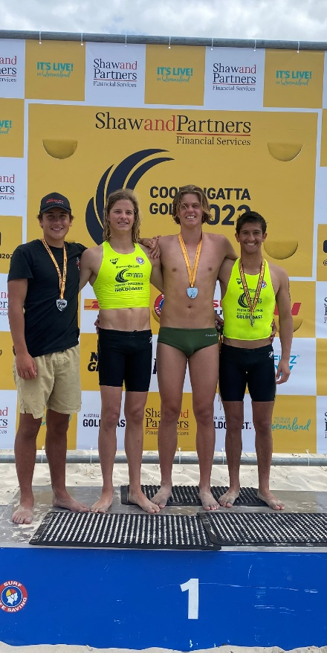

**U17 Coolangatta Gold Team**

**LNC Branch Carnival**

Black Head SLSC was again the dominant club in our branch, with too many excellent results to mention as a club we accrued almost as much points as all other clubs combined. An amazing effort.

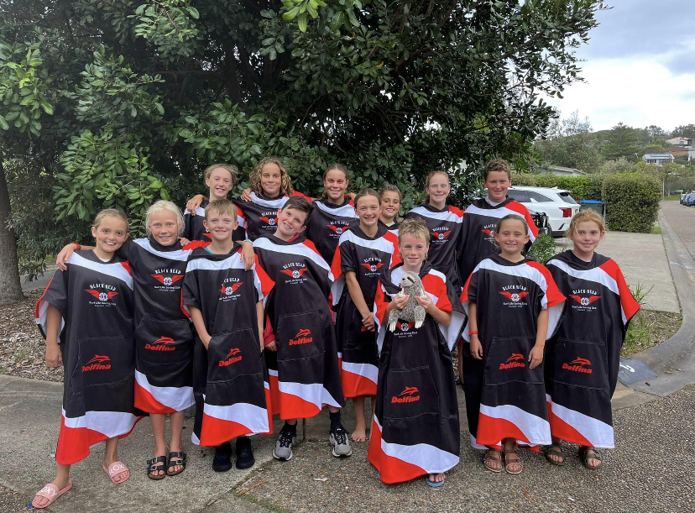

**Junior State Team**

**2023 SLSNSW Country Championships**

With a predominantly water-based team entered Country Championships this season Black Head SLSC punched well above its weight. Finishing 8th overall in the points score our medal tally was impressive. Tully Kippax again won gold in the U10 board race and Izaac Boag won the U17 ski race and 2km beach run. Freya Raglus won gold in the U19 2km beach race and Michael Kippax won the Over 40 short and long board finals as well as Miley Cox in the U14 short board-riding.

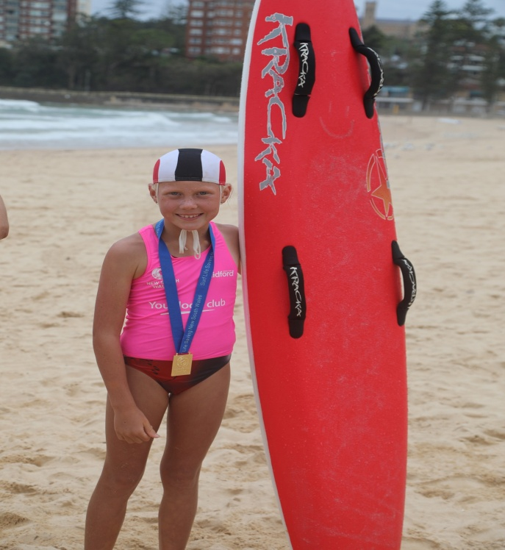

**Tully Kippax**

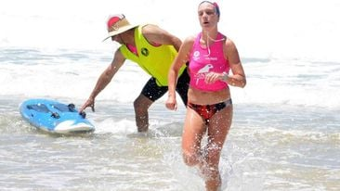

**Freya Raglus**

**State Championship**

SLSNSW State Championships was again held at Queenscliff and Manly beach this season. Again mother nature gave our competitors some tricky conditions. All our competitors gave their best with some excellent results. Our U13 female board relay team of Bronte Kippax, Ashleigh and Ella Pegrum won gold and Tully Kippax finished 2nd in the U10 female board race. Again, Freya Raglus put in a massive effort to win silver in the U19 2k beach run.

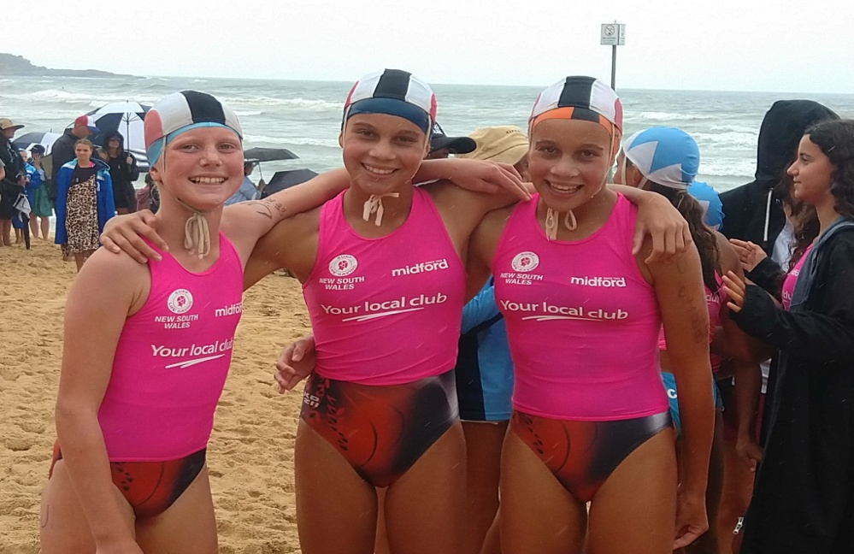

**Bronte Kippax, Ella Pegrum & Ashleigh Pegrum**

**Aussies 2023**

Miley Cox, Bronte Kippax, Ella & Ashleigh Pegrum and Izaac Boag all travelled over to Perth for The Aussies. All competitors made either finals or semifinals.

Kevin Boag





**Junior Activities Annual Report 22-23 Season**

Wow, what a fantastic learning experience it was to have completed my first year as Junior Activities Co-Ordinator for Black Head Surf Life Saving Club. I thank you all for your endorsement in taking on this role, and the support that I received throughout the year.

Image

The 2022-2023 Nippers season again showed the strength of our junior participants with a total of 134 Nippers registering this year. This included many return Nippers families and new Nippers families. This saw an increase of 19 Nippers on the previous year.

The arrival of new families gave us very strong numbers in our 6’s and 7’s age groups, which bodes extremely well for the future of our Nippers Program. The addition of these kids also led to many of their parents completing Bronze Medallion training and, as such, an increase in our patrolling member numbers. I would like to extend my thanks to this group for their commitment to the community and Black Head SLSC.

Our Nippers enjoyed a fairly uninterrupted Nipper’s season, which was great to see after a number of years of regular poor weather and the impact of the COVID pandemic. The kindness of the weather and surf conditions enabled our children to develop their experience and confidence in surf related activities. Hopefully this development will continue and, as a result, we will continue to educate these kids to a level where we can all be confident in their abilities in and around the water.

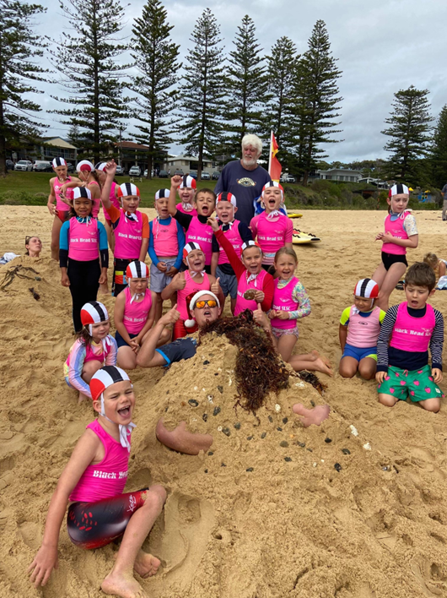

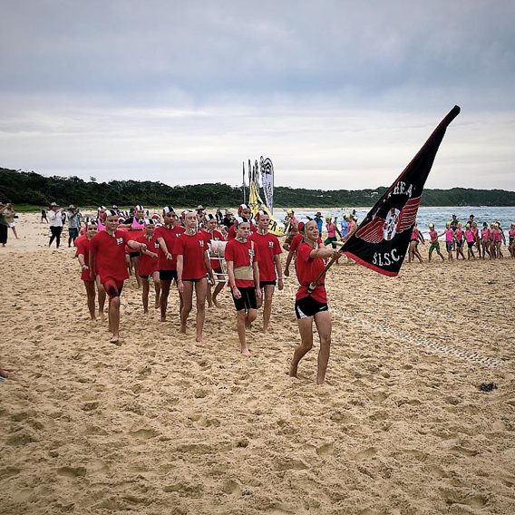

In addition to Nippers, our “L” Plate board program ran again before nippers on Sunday Mornings. This group of enthusiastic kids are aiming to develop their skills in competitive board riding and a number of them are now beginning training with the Black Head Surf Sports Team.

On the competition front, Black Head Nippers again performed extremely well, with our Nippers dominating the LNC Branch Championships. Many of these kids having never competed before. A highlight of this year was the return of a Black Head SLSC Junior March Past Team who competed at both the Branch and Country Championships. Made up of Nippers, captained by Miley Cox and coached by myself, our kids did our Club proud at both events, winning the Branch Championships and performing admirably at their first Country Championships. The tradition of this event being embraced by our kids is something to behold.

Of note, and I know this will be covered in more detail by our Director of Surf Sports, Kevin, I would like to pass on our congratulations to all our Nippers that competed at the Country, State and Australian Surf Life Saving Championships. You are all amazing kids and are a fantastic endorsement of the junior programs at Black Head SLSC

Nippers does not run without helpers, and this year we had a number returning and new Age Managers. Nippers cannot run without you, and for that, we are extremely grateful. Particular recognition goes to our two youngest Age Managers, Freya Raglus and Miley Cox, who took on the very talented and energetic Under 10s group of Nippers, having only just completed the Nippers program themselves. This step will hopefully be repeated again, with a number of lasts season’s Under 13s becoming Assistant Age Managers for next season.

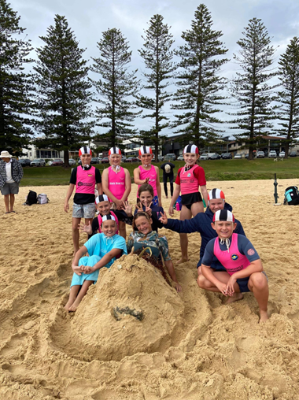

I would like to thank our BBQ team for this season. The burnt snags and hard eggs helped raise in the vicinity of $6000 towards funding our nippers program.

Finally, a big thank you to Tania McKone, from whom I took over the JAC role. Your assistance and advice was greatly appreciated, and the time and effort that you committed to 2 very successful disco nights and a fantastic “Nippers Christmas” was outstanding.

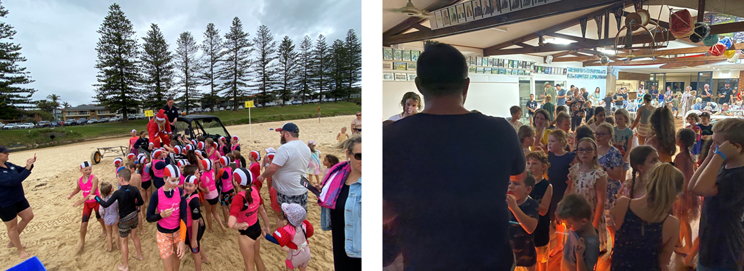

To all the Nippers family, I look forward to seeing you at the end of September for season 2023-2024.

Any parents/members that would like to assist in roles with Nippers, your help would be greatly appreciated.

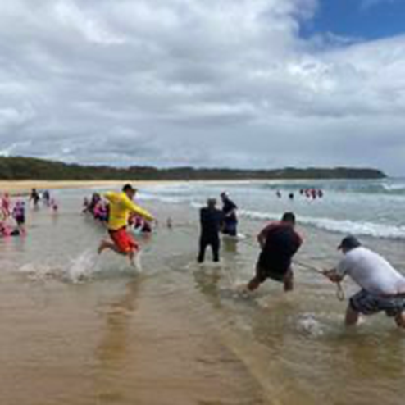

Ian Marshall