How to vote to fix the Black Head Toilets
Put MyServiceNSW in your search engine (Explorer or Chrome)
Look at second column and press Sign Up
2 options Login if you have signed up in the past (you’re ready to vote) or
Sign up if you haven’t registered to MYSERVICENSW before.
You then need your email address and setup a password;
They will send you an email to check that you are real,
Put in your Medicare number and its end date, DOB, address,
Now Login with your email and Password, you will go to
the Dashboard.
In second column under press
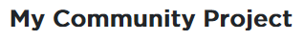
At go to
Press the arrow to go down to
Then hit

This takes you to a map, scroll down till you see The Black Head Toilets and press
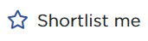
you may be told to login, again, just be calm and login again.

Now short list Black head toilets and 2 other projects of small amounts.
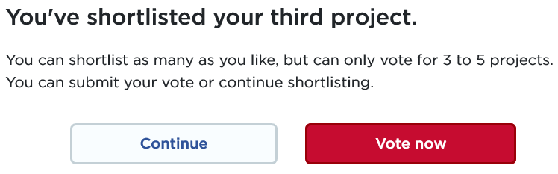
You then get the dropdown
Press Vote Now. The 3 you pressed are there.
It’s important to make sure our project is No. 1
Then press Thank you, you have earned a stiff drink.
Dr Bruce White
Black Head Surf Club
President@blackheadslsc (0428294483)
Let’s Fix the Black Head Toilets
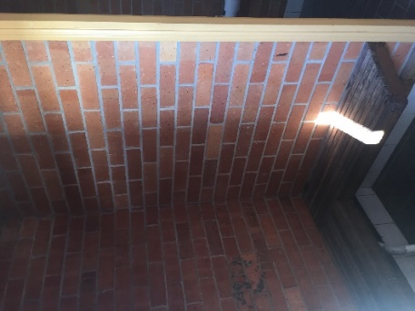
The public toilets at the Black Head pool are terrible.
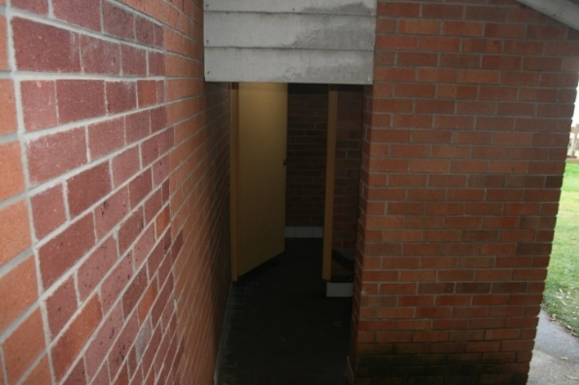
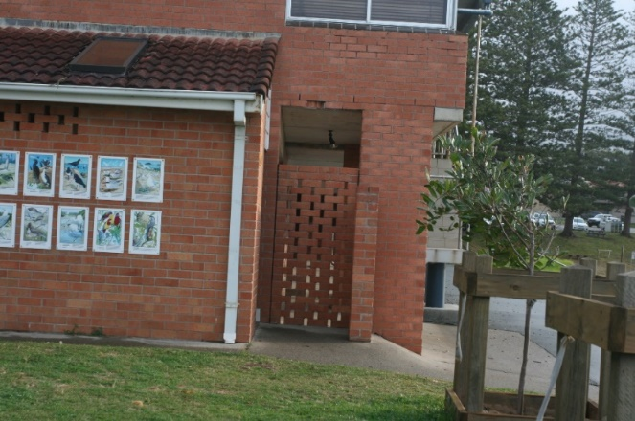
We now have a real chance to FIX them by simply VOTING.
There is grant money available to do 3 out of 20 projects.
If enough people vote to fix the toilets-we get them fixed.
You can vote if you are over 15 years old, live in NSW and
have a Medicare card (to confirm its you). You vote 1,2 & 3.
Put the Toilets No. 1, with 2 smaller projects 2nd & 3rd.
Vote by 1) go online through ServiceNSW [see over] or
2) visit the RMS centre in Tuncurry or Taree. or
3) visit the Surf Club on Sundays, 2:30-6.
Please turn-over for voting instructions
We only have until 15/8/2019
If we get enough votes, we fix the toilets. Simples.

Dr Bruce White
Black Head Surf Club
President@blackheadslsc (0428294483)

