Notice
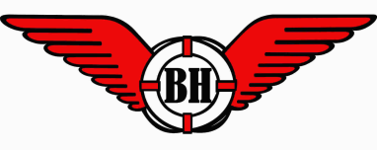

Founded 1925

Reg No. Y2944746 ABN 39153927691 BlackheadSLSC.com.au
All correspondence to: Director of Administration, PO Box 55, Hallidays Point, 2430
administration@blackheadslsc.com.au

The 94th Annual General Meeting

of the Black Head Surf Life Saving Club

will be held at the club on Sunday 18th August 2019 at 13:30

Agenda

Apologies

Confirmation of the Minutes of the AGM held in 2018

Presentation and adoption of the Annual Report.

Presentation of the Financial Report and Balance Sheet

Election of Office Bearers for the 2019-2020 Season

Notice of Motion

Affiliation to be sought by Black Head SLSC

with SLS Lower North Coast Branch & SLSNSW

Members wishing to nominate please use the enclosed form.

Please have nominations in 1 week prior to the meeting.

The bar will be open at the end of the meeting

-------------------------------------------------------------------------
NOMINATION FORM FOR BOARD POSITION 2019/2020

Nominated Position: ______________________________

Nominator 1 & Sign: ______________________________

Nominator 2 & Sign: ______________________________

Member & Sign: _________________________________

By signing I accept the nomination & confirm I have read the responsibilities and skills required.

